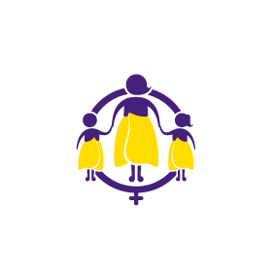
Position Advertised

Service Development Support (SDS)

About us

NCIWR (Women's Refuge NZ) is New Zealand's largest provider of services to women and children impacted by family and domestic violence. We work to drive long term transformative change by providing quality frontline services, raising community awareness and advocating for social change. We do this by working collaboratively with a range of government and non-government partners.

About the Role: Fixed Term – 12 Months

We have a vacancy for a Service Development Support role. The SDS role is a Fixed Term position for 12 months, based at our national office in Wellington and will work throughout New Zealand communities with our 40 affiliated refuges. The role supports the national office operations to provide services to affiliated member refuges, so that NCIWR is an effective and sustainable not-for-profit organisation working in the Family Violence Sector, New Zealand.

The purpose of the Service Development Support role is to develop and maintain respectful relationships with member refuges while supporting them to meet compliance and membership obligations. Finely developed written and verbal skills and an ability to remain impartial and non-judgemental are essential skills required for this position. Furthermore, the role will require working alongside agents of Government Agencies and maintaining professional working relationships with these agencies will be critical.

This position is expected to be professional, a team player and support outcomes for both Māori and Tauiwi.
This role will have regular involvement with member refuges.

Key Requirements for this role:
- Ability to travel frequently with overnight stays away from home is essential
- Support ongoing risk management strategies relating to NCIWR policies and procedures

Key performance areas:
- Information gathering, evaluation, interpretation
- Planning and project management skills
- Exceptional report writing skills

This is a fulltime position based at the National Office in Wellington. A minimum of three years senior administrative experience within community development or relationship management, implementing policies and practices and/or a community audit function is desirable. It is advantageous but not essential to have relevant experience working in community development or for a not-for-profit organisation.

The successful applicant will be required to undergo reference checks and security clearance.

Visit our website for an application form and a full job description at https://womensrefuge.org.nz/about-us/work-for-us or request one directly from cheryl@refuge.org.nz For further information: Contact Cheryl Gibbs at 04 802 5078

To apply: Complete an application form and submit to us along with your cover letter and CV to cheryl@refuge.org.nz

Applications for this role close at 12 noon on 30 September 2021.

